If we create a ingress we there will be a separate loadbalancer created for the ingress, 100s of loadbalancer is not costeffective and one huge is not modular and secure enough

So we create gateways

Gateway class

Gateway

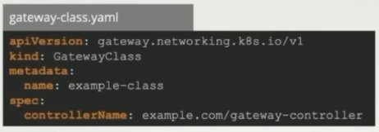

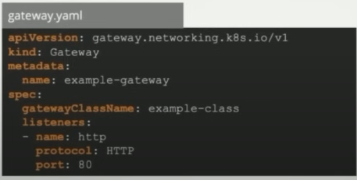

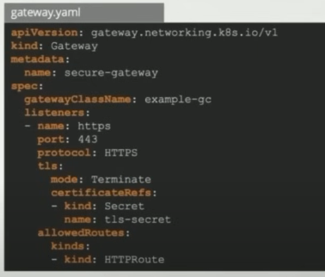

HTTP route ---- there are different routes available for all layers of routing

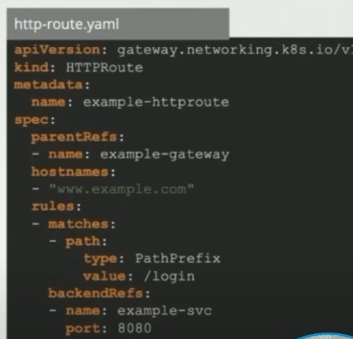

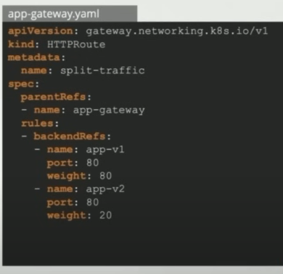

similar to canary annotations rules in ingress